**Usage manual**

**Installation guide**

1. Do install the mobile application of **MIT App Inventor 2** from the **Google Play** store.

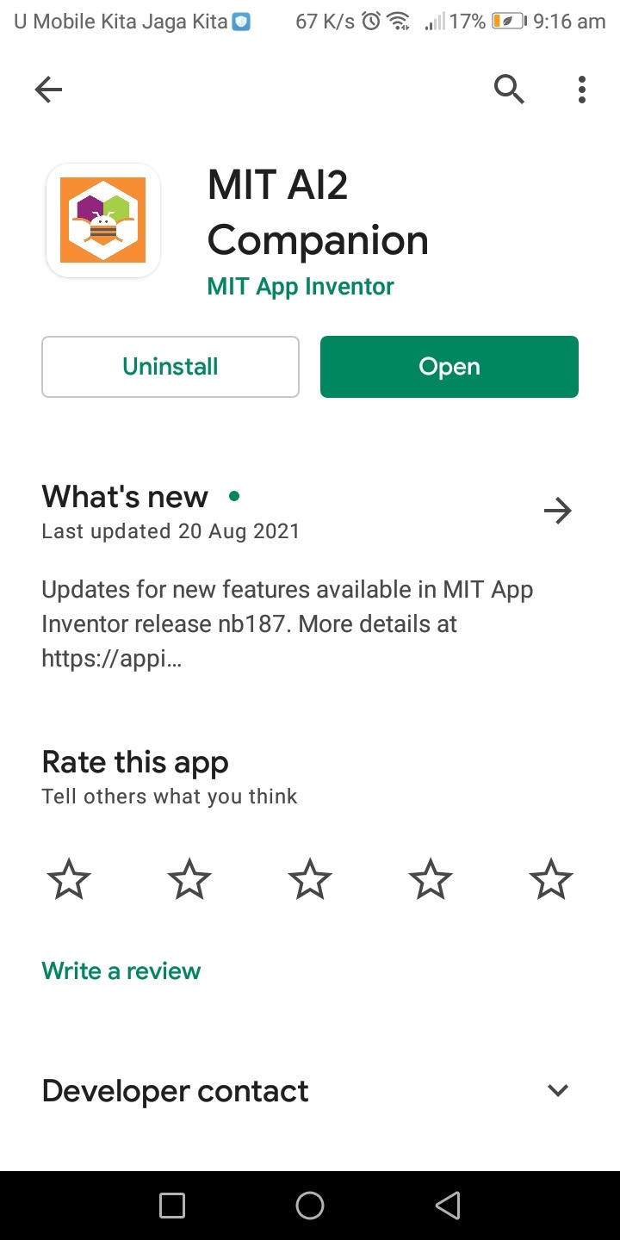

1. Download the project (Final_BMI.aia) from the **GitHub** link <https://github.com/jiehyi/TCC-3141-Cloud-Computing_assignment>

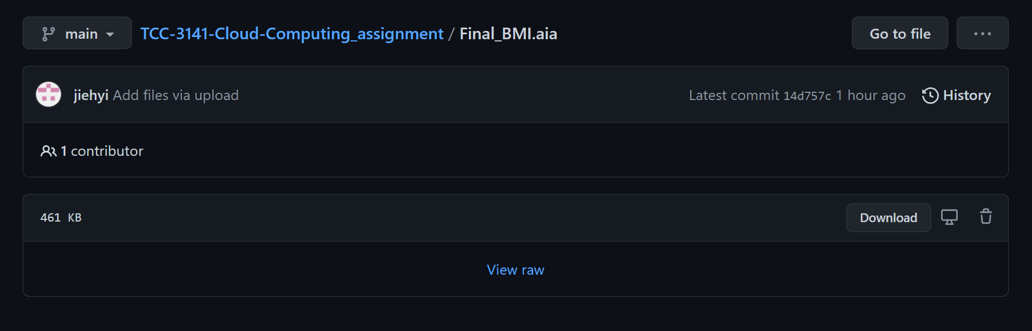

1. Upload the file to the MIT website <https://appinventor.mit.edu/> , you are needed to register an account at MIT before using the MIT website and mobile application. Upon successful registration, your screen will show:

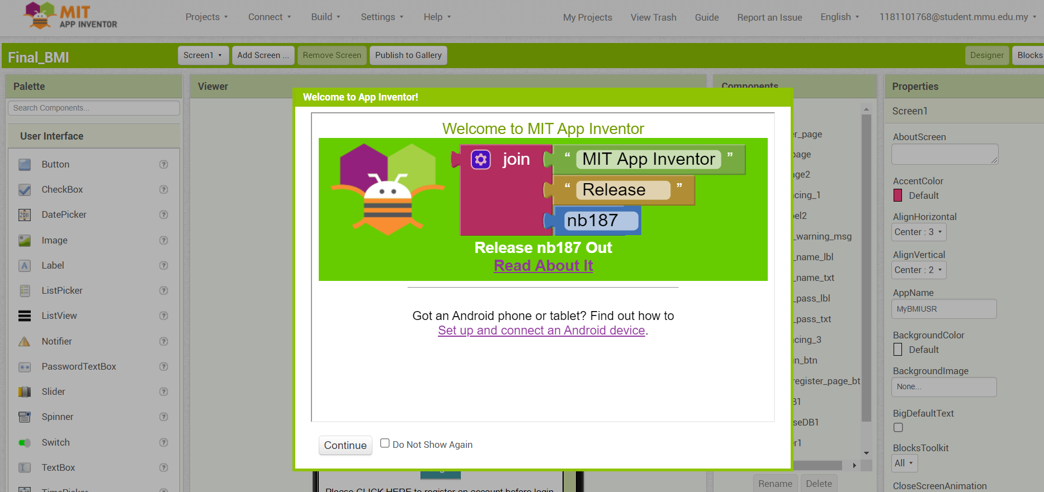

1. To connect and run the .aia file, go to Projects > Import project (.aia) from my computer

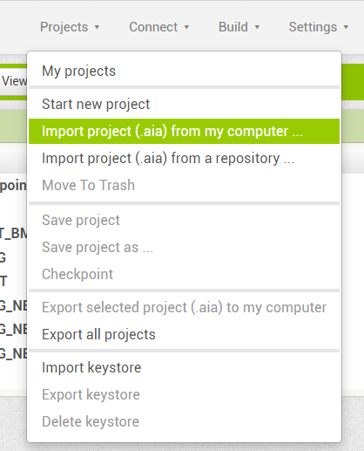

1. You are required to choose the downloaded (.aia) file from your local computer

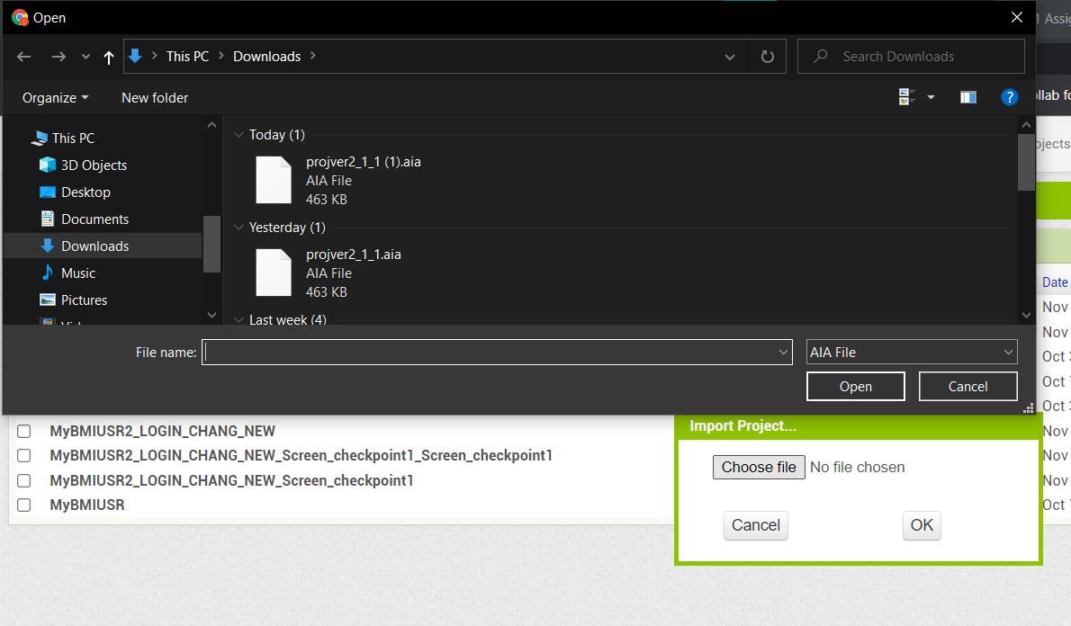

1. To connect and tun the prototype please ensure that your mobile device and website are connected to the SAME WiFi Network, and select Connect > AI Companion

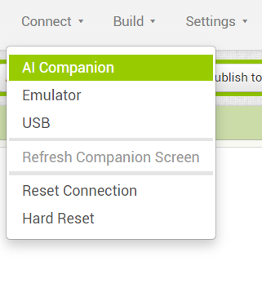

1. Upon selecting the AI Companion, a pop-up screen with QR code and code could be seen, in your mobile device, you could choose the option to connect with code or scan the QR code to connect.

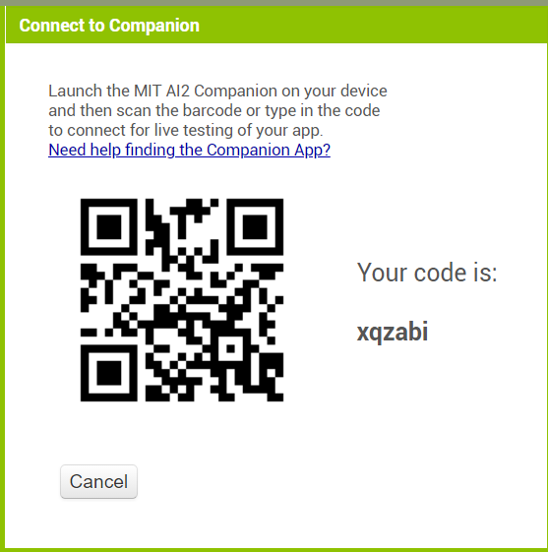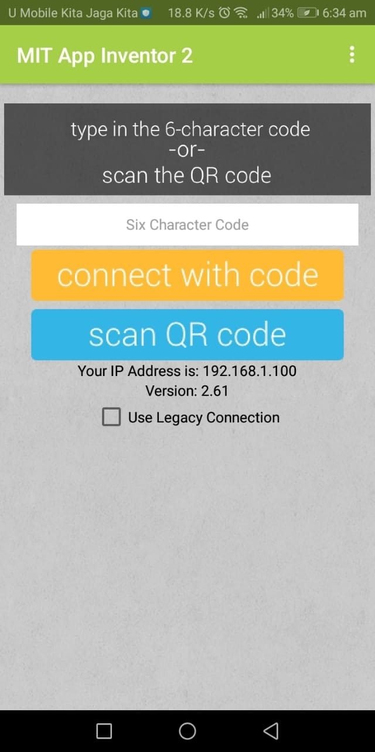

1. Upon succeeding, you will see a progress bar indicating establishing connection at the MIT website.



1. After the loading is complete, you will see the prototype displayed on your screen

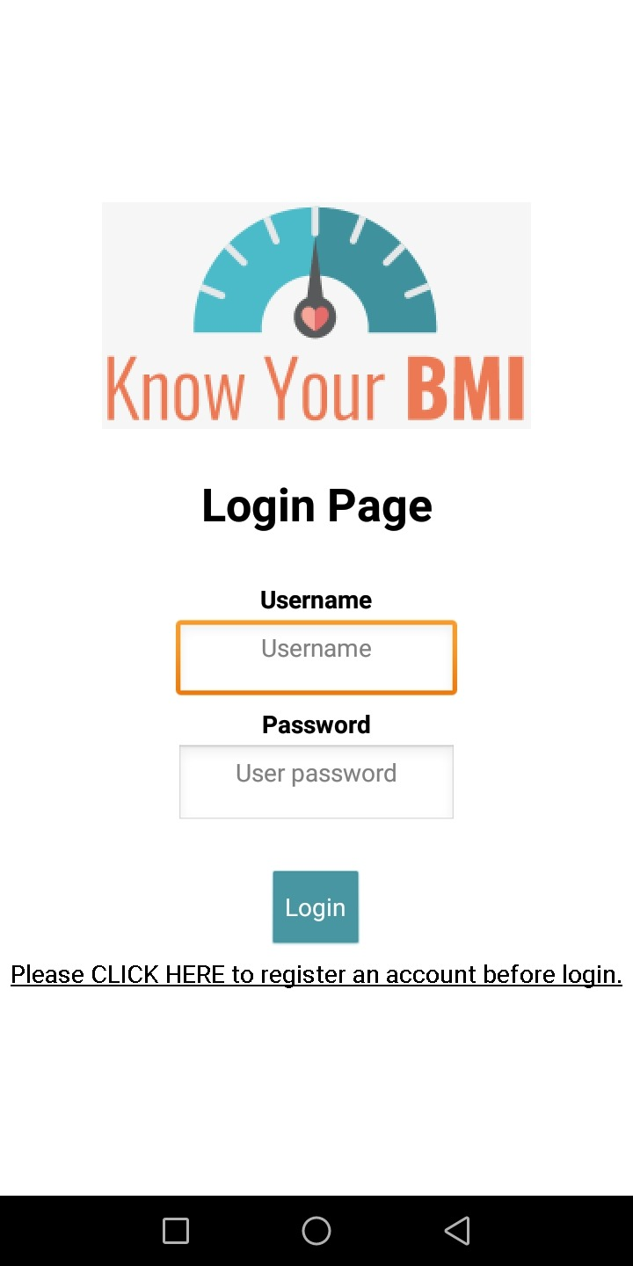

**Prototype**

**Registration page (for new user)**

1. Registration Page- users are required to fill up their name, age, gender, and password

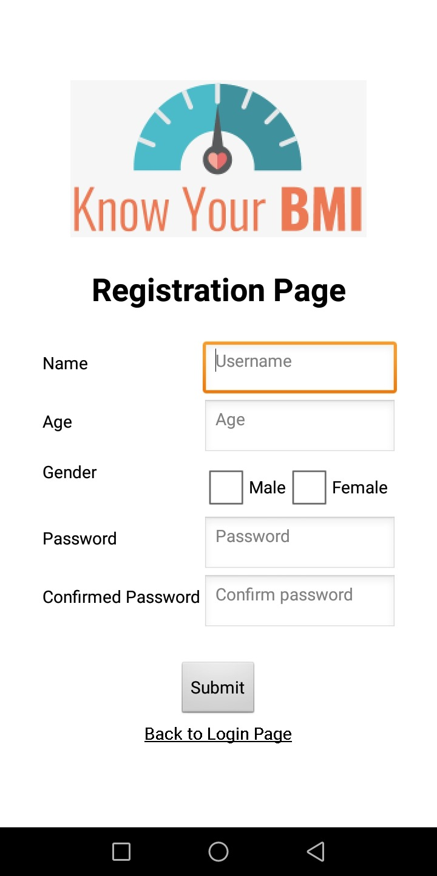

1. If user do not fill up all the required fields, error message will be display respectively.
   1. Error message (User’s name)

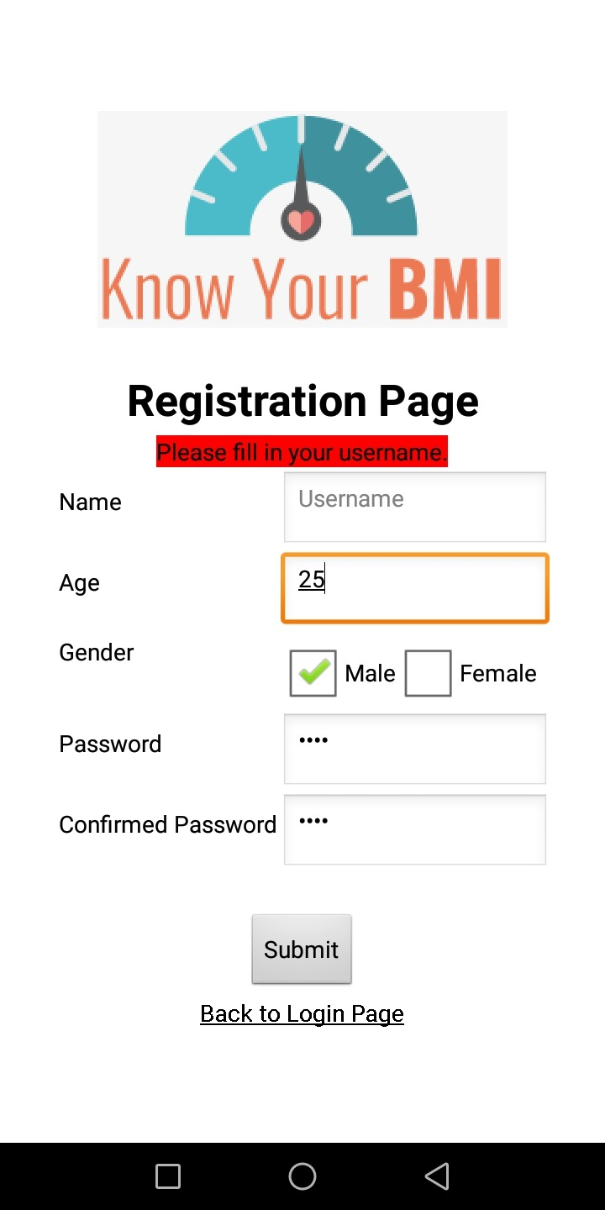

* 1. Error message (User’s age)

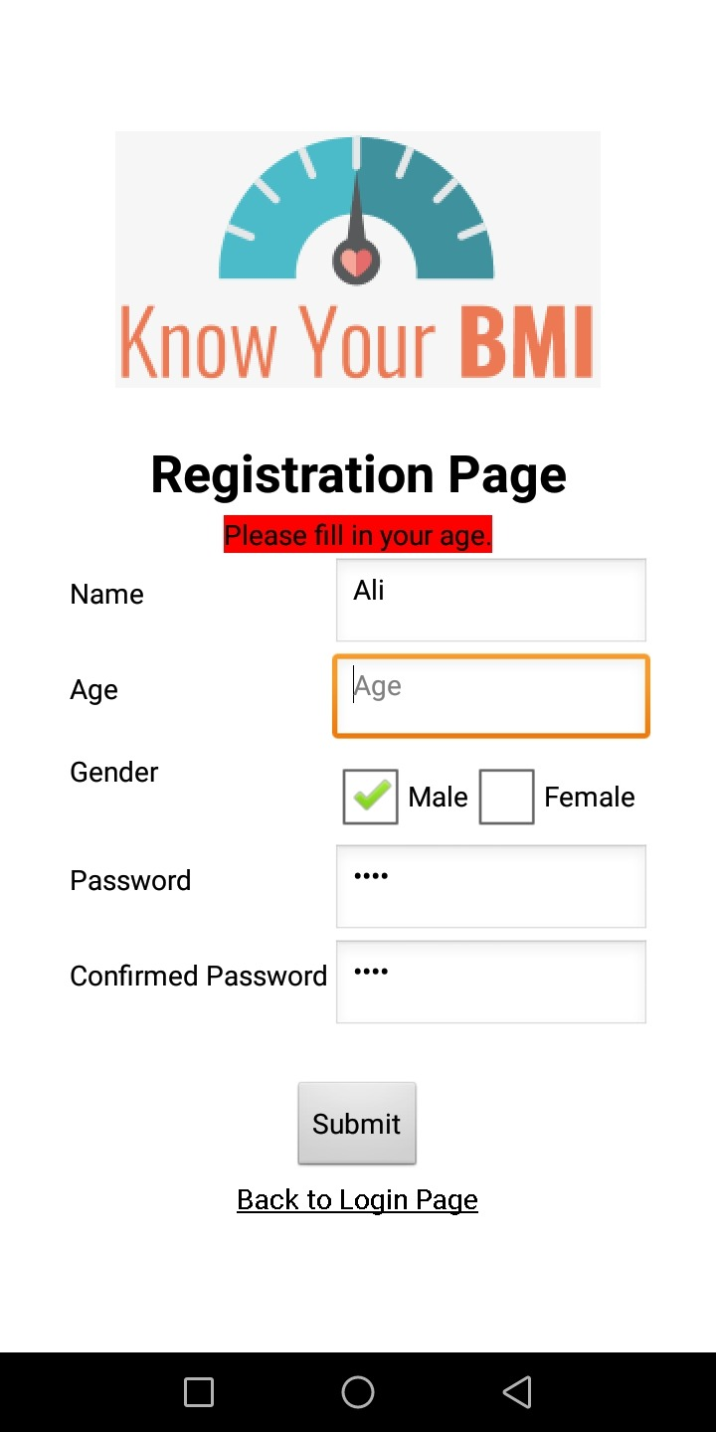

* 1. Error message (User’s gender)

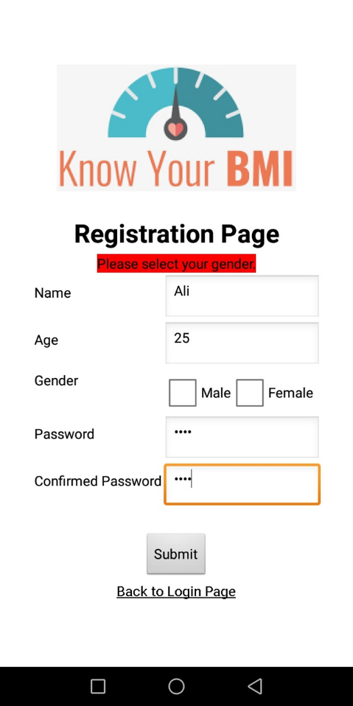

* 1. Error message (User’s password)

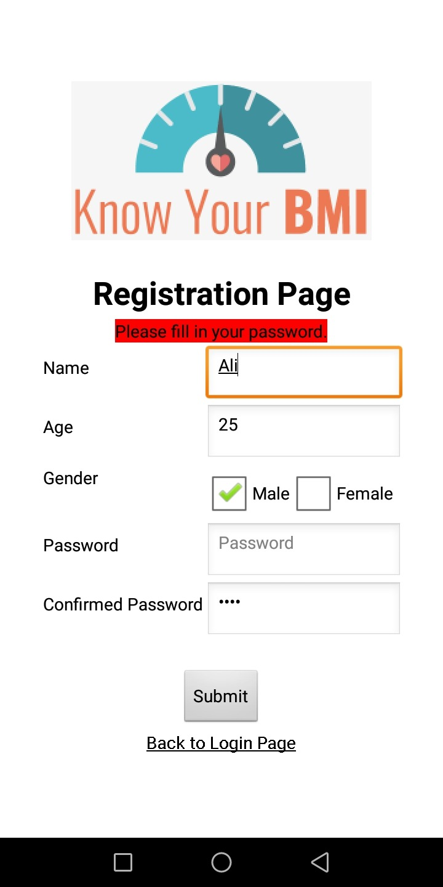

* 1. Error message (Unmatched password)

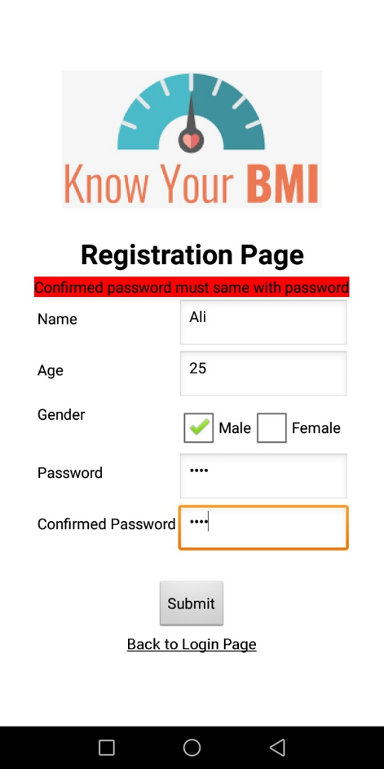

* 1. Error message (Duplicated user)

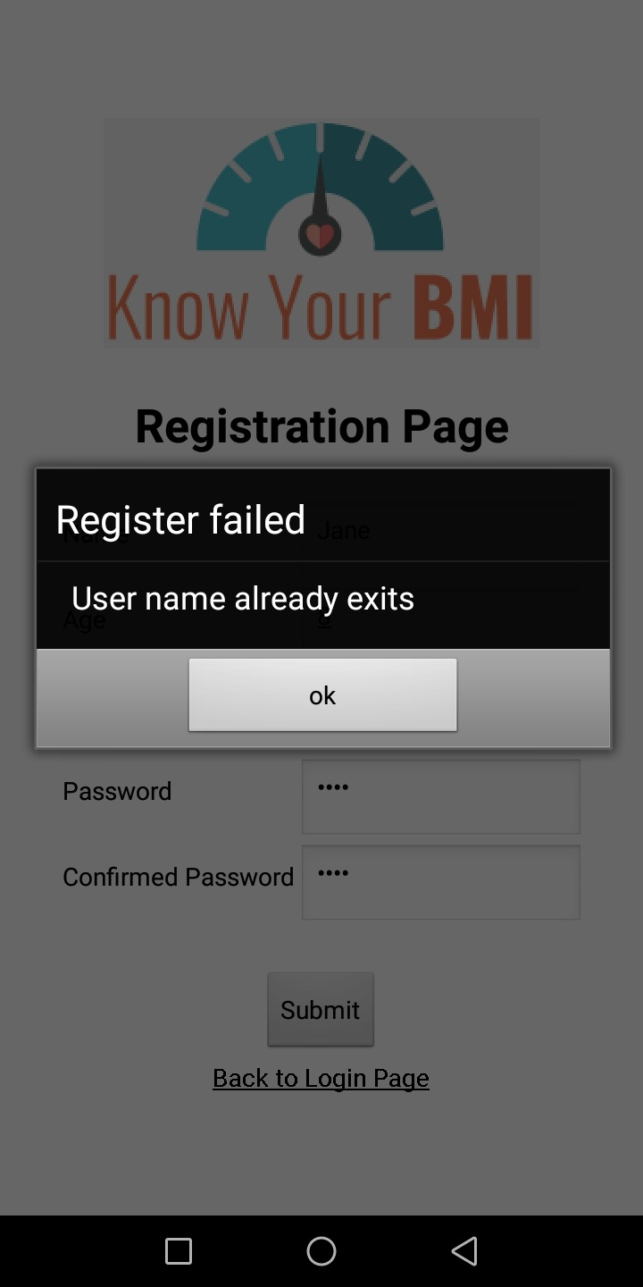

1. If successfully registered, the message will indicate message of “Register Successfully”.

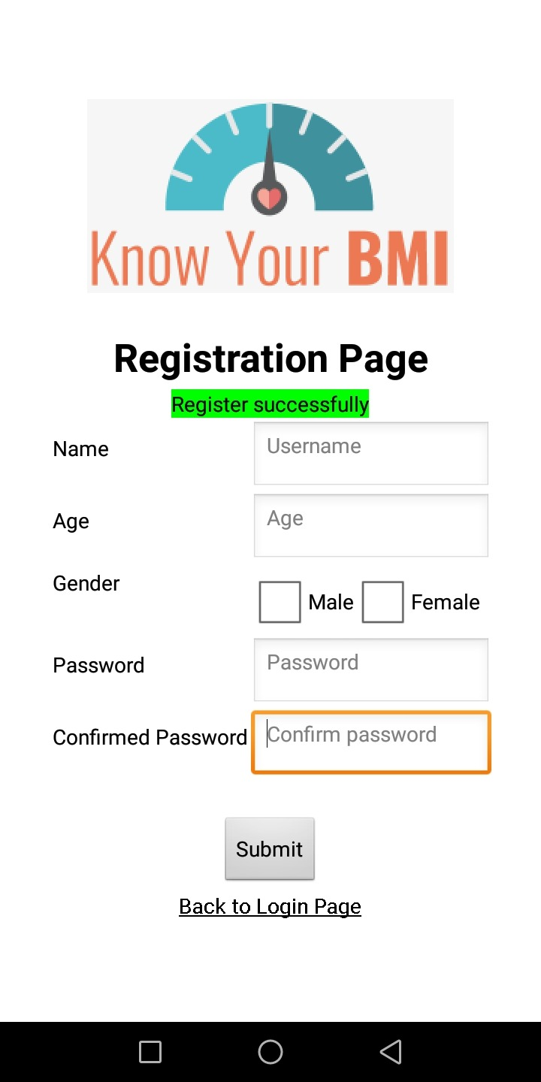

**Login page**

1. The login page will indicate username and password with registration page.



1. Error message will be display if one of the fields is user enter an invalid password or misfiled one of the fields.
   1. Error message (Username)

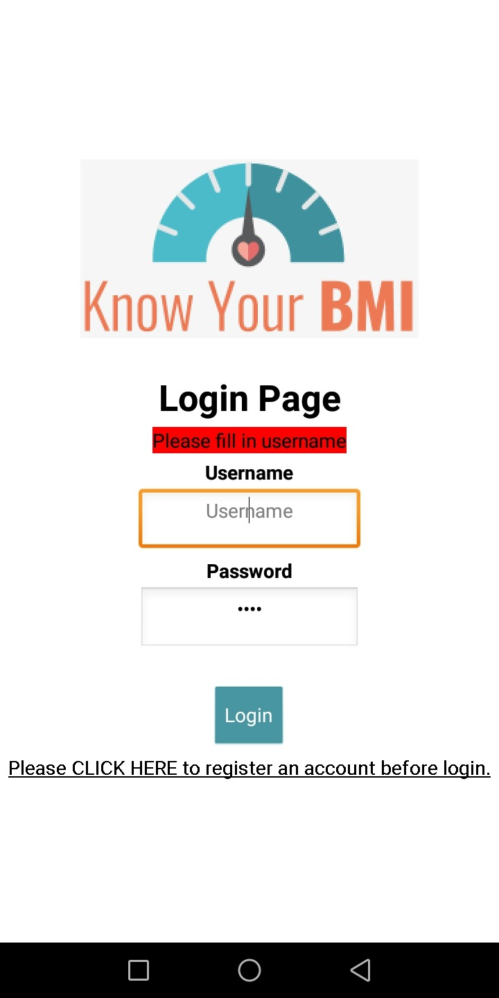

* 1. Error message (Password)

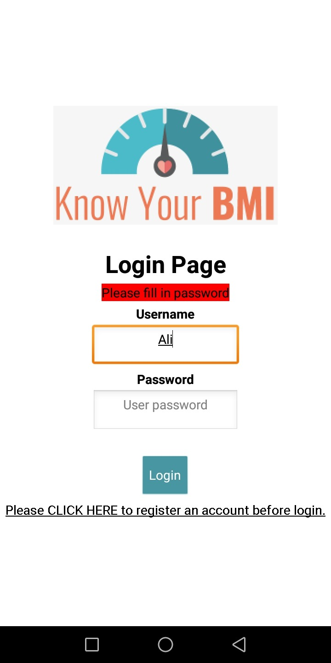

* 1. Error message (Invalid password)

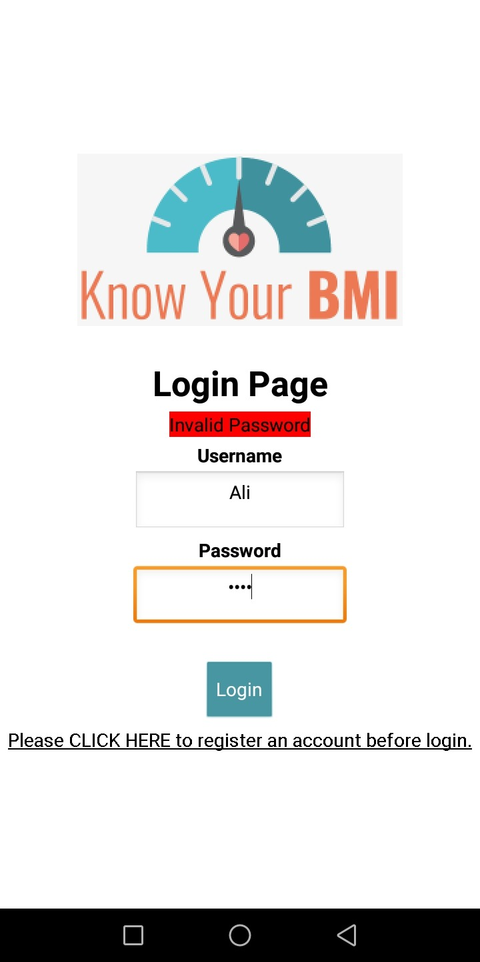

1. If successfully login, the message will indicate message of “Login Successfully”.

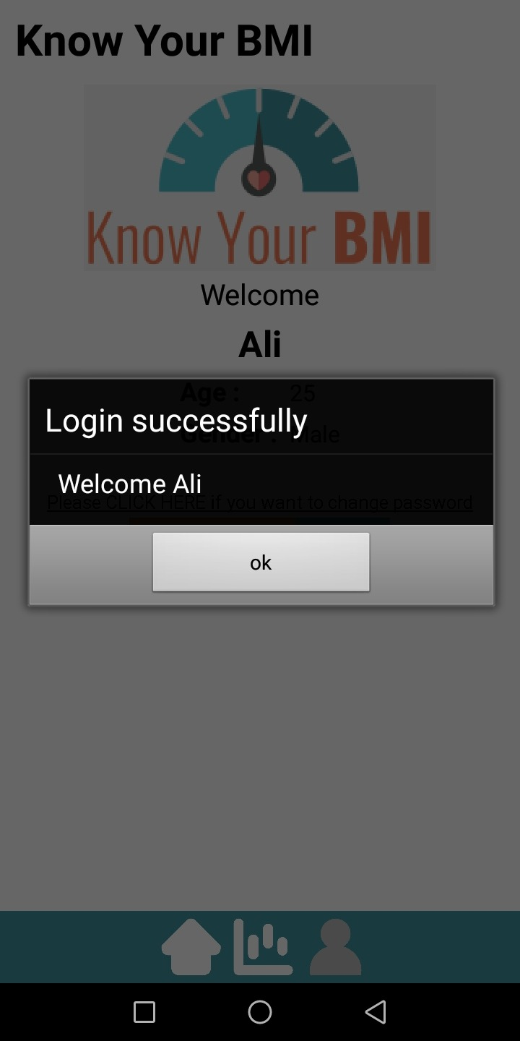

**User profile**

1. User profile will display information of user with button for logout or delete account, and a page for changing password.

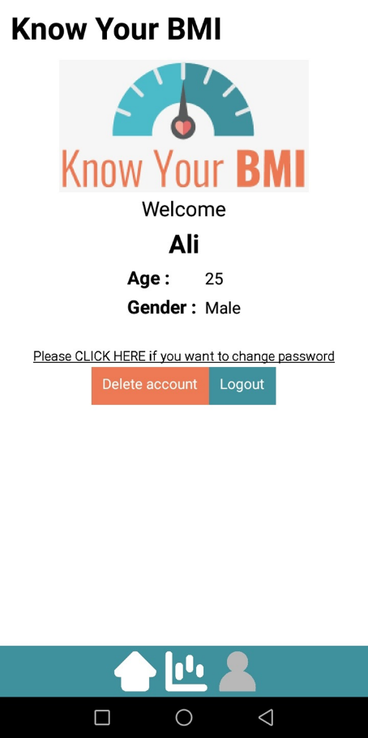

**Changing Password**

1. To change password, the system will display user’s old password along with fields for new password.

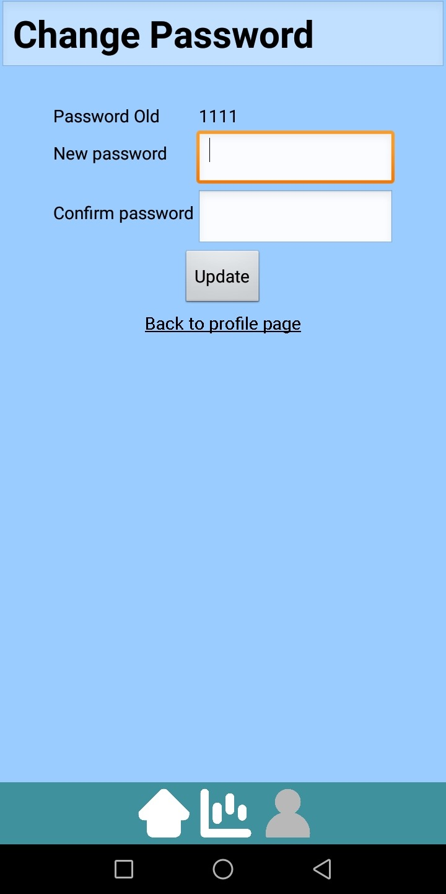

1. If error occurred due to password mismatch, the system would display related error.

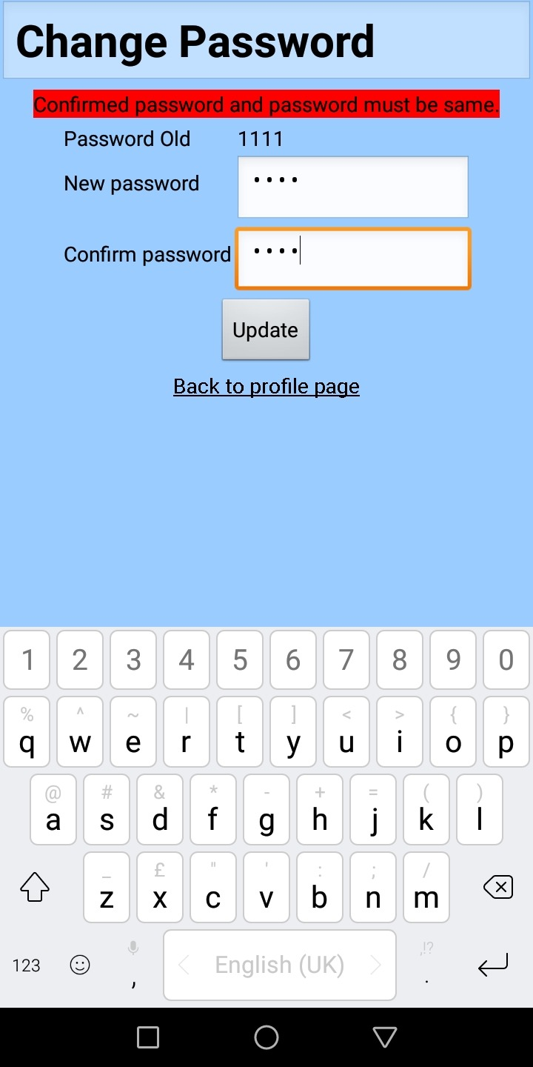

1. Once successfully change the password, the message will indicate message of “Password Update Successfully”.

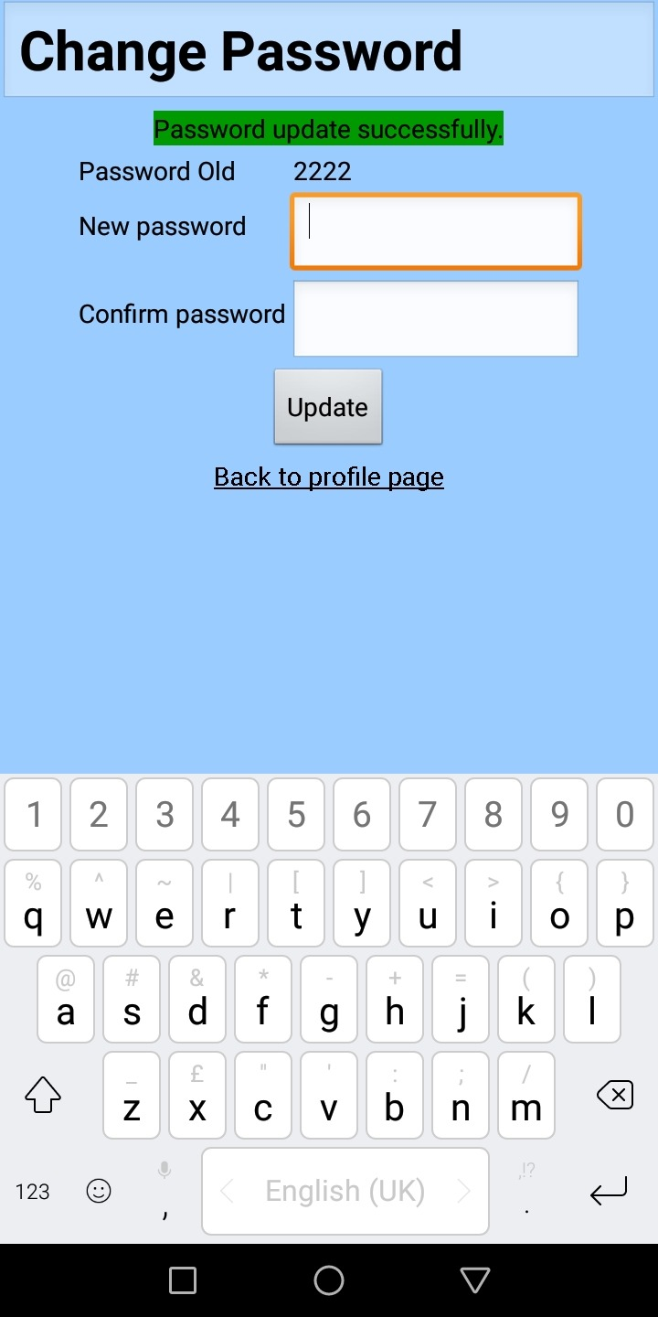

**Logout**

1. Before logout, confirmation message will be displayed.

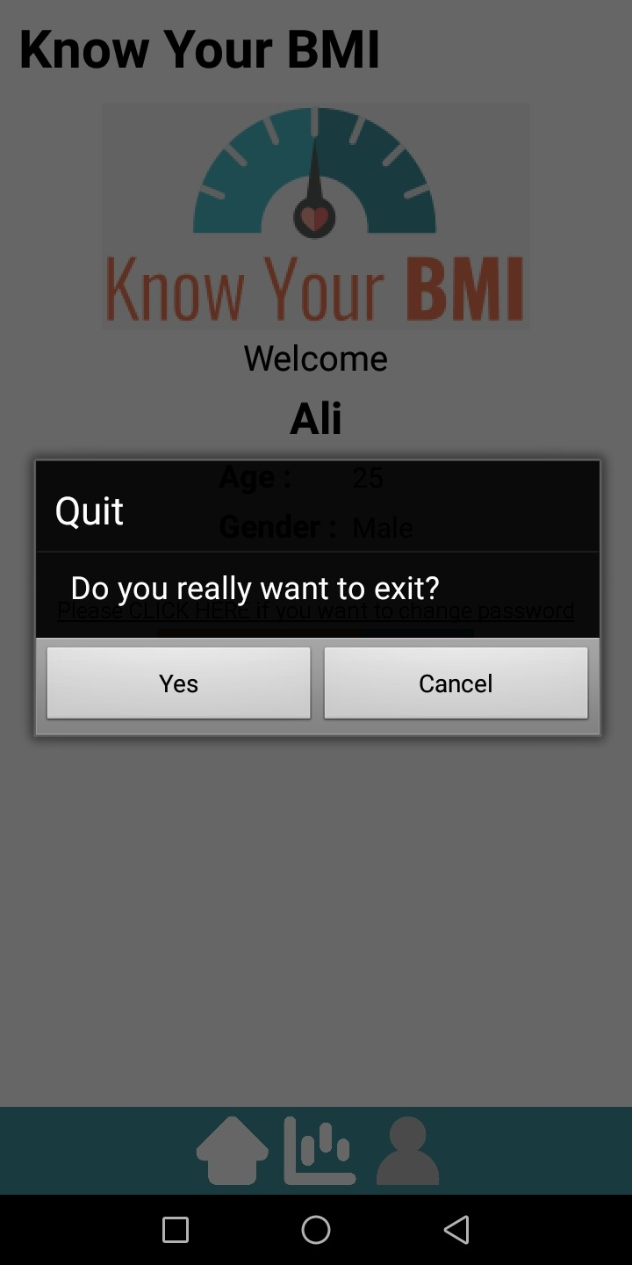

**Delete account**

1. Before delete the account, confirmation message will be displayed.

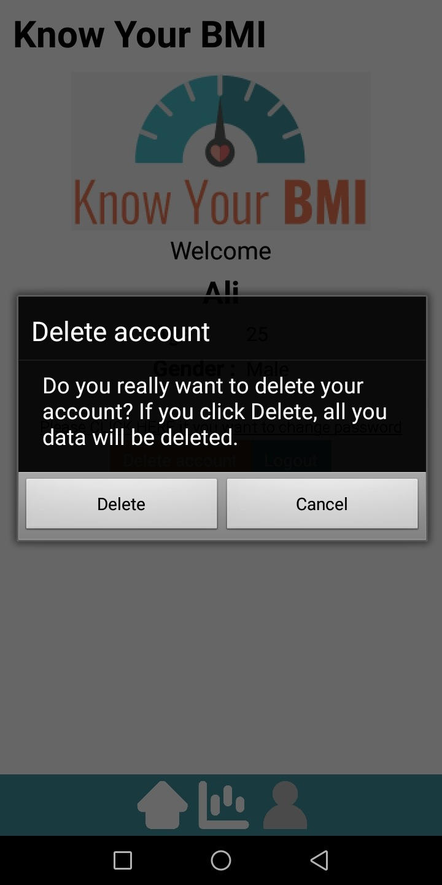

**BMI Calculator (Adult)**

1. Below displays the BMI calculation for male adult named Ali aged 25.

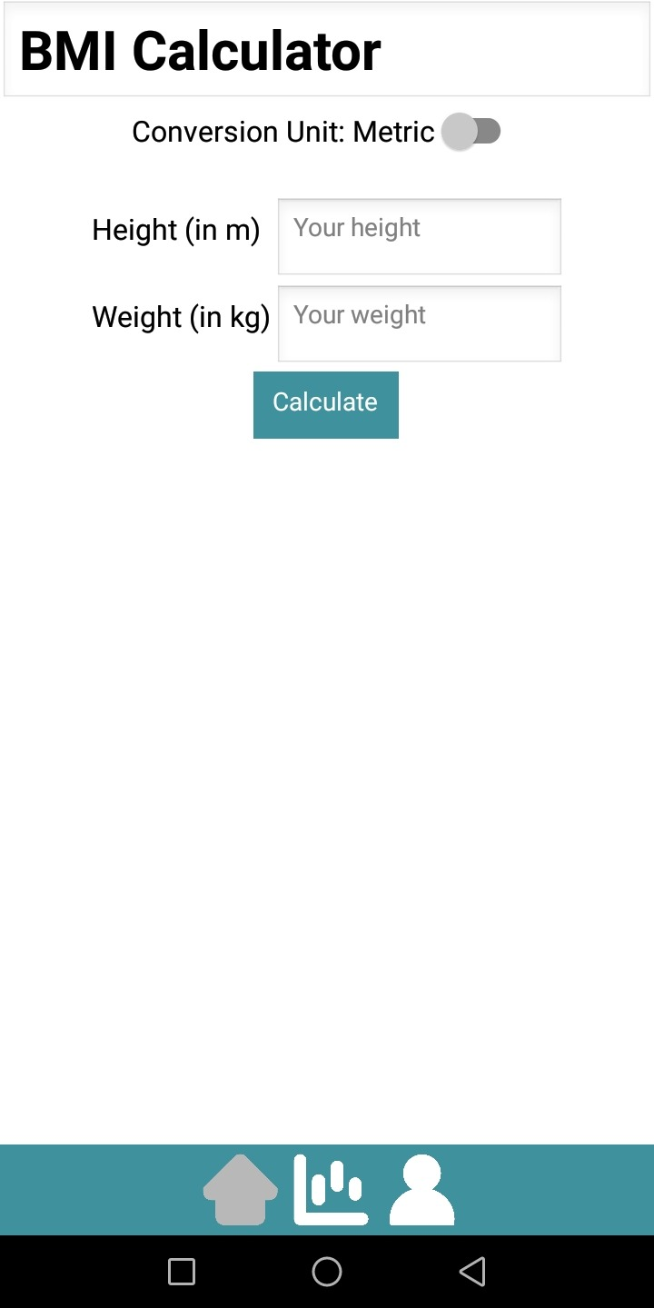

1. The output of BMI consists or normal, underweight, overweight, and obese.
   1. Normal

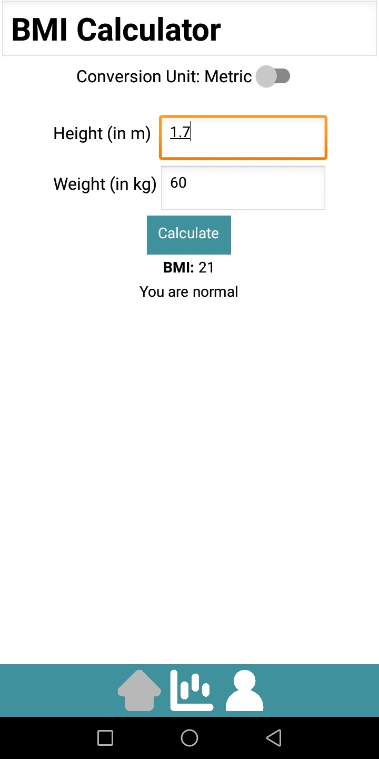

* 1. Underweight

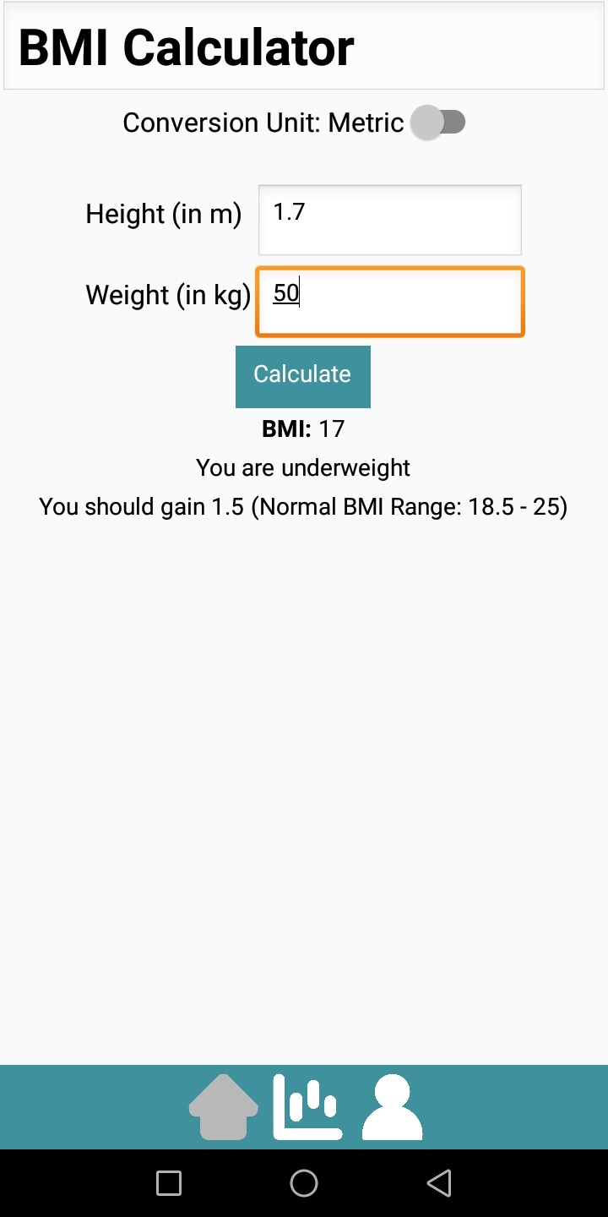

* 1. Overweight

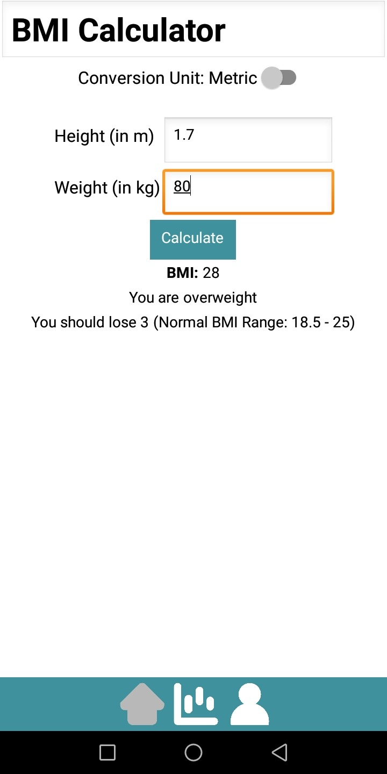

* 1. Obese

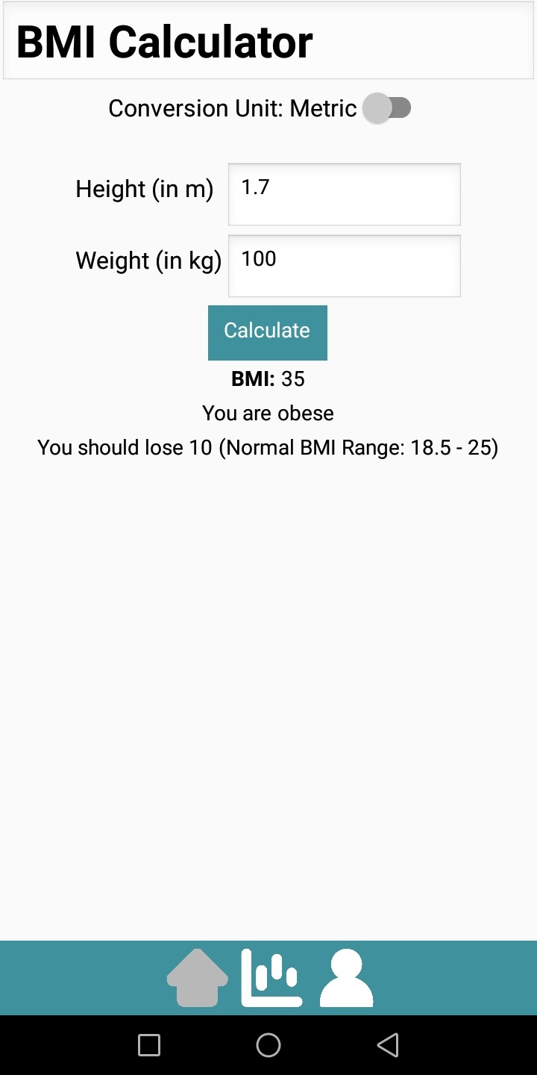

**Conversion Units**

1. For the BMI application, we have conversion units of Imperial and Metric. By default, the system is set up to Metric.
   1. Metric



* 1. Imperial

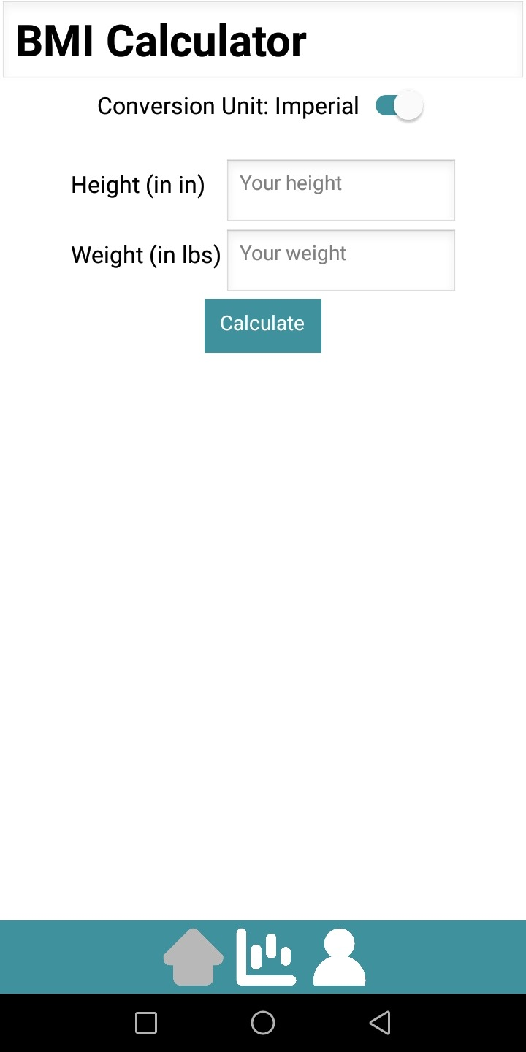

1. The unit of Metric for Height and Weight are meter (m) and kilograms (kg). For Imperial, the Height and Weight are inches (in) and pounds (lbs). Both conversion units will display the same BMI output.
   1. Metric



* 1. Imperial

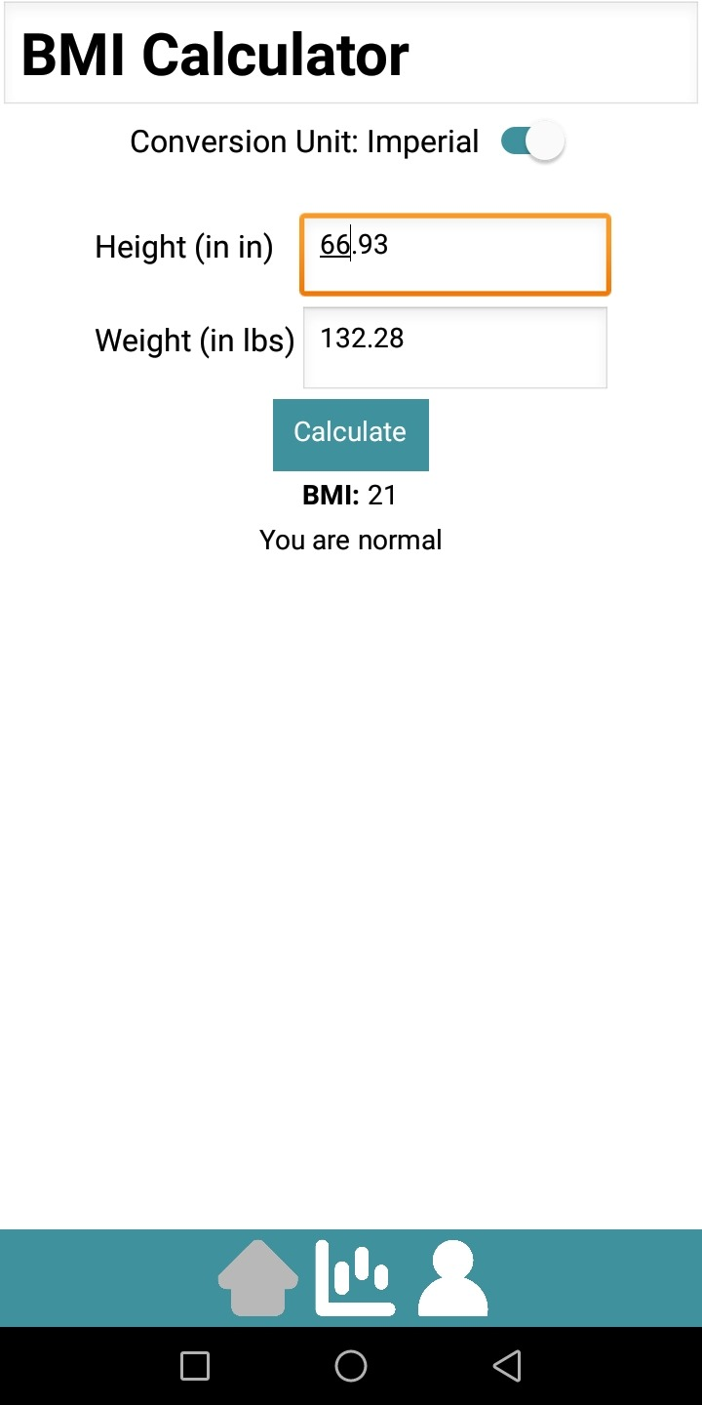

**BMI Chart (Adult)**

1. The BMI Chart will display the expected changes of BMI across 6 months and comparison of user’s BMI with BMI range of normal, underweight, overweight, and obese.
   1. Normal- BMI are expected to remain unchanged across 6 months.

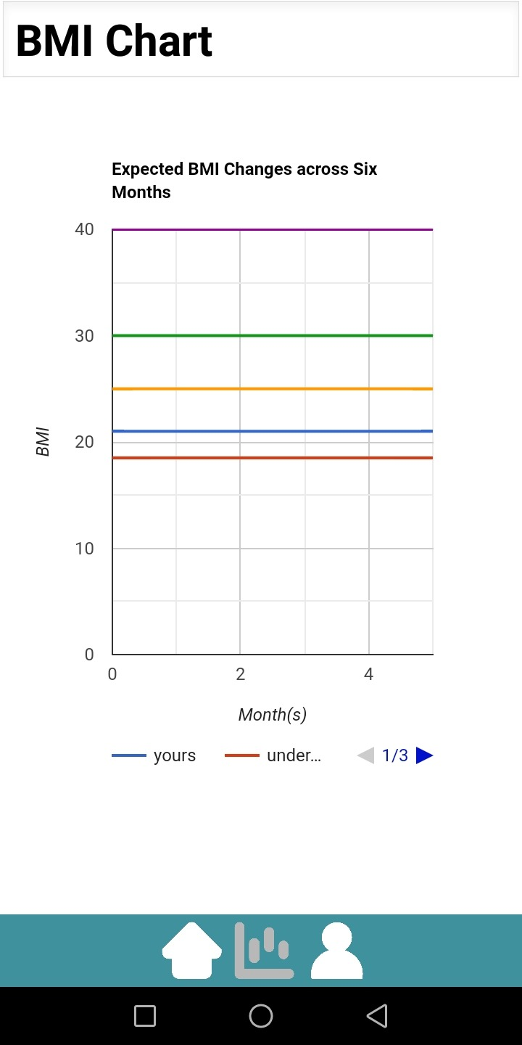

* 1. Underweight- BMI are expected to increase towards Normal range across 6 months.

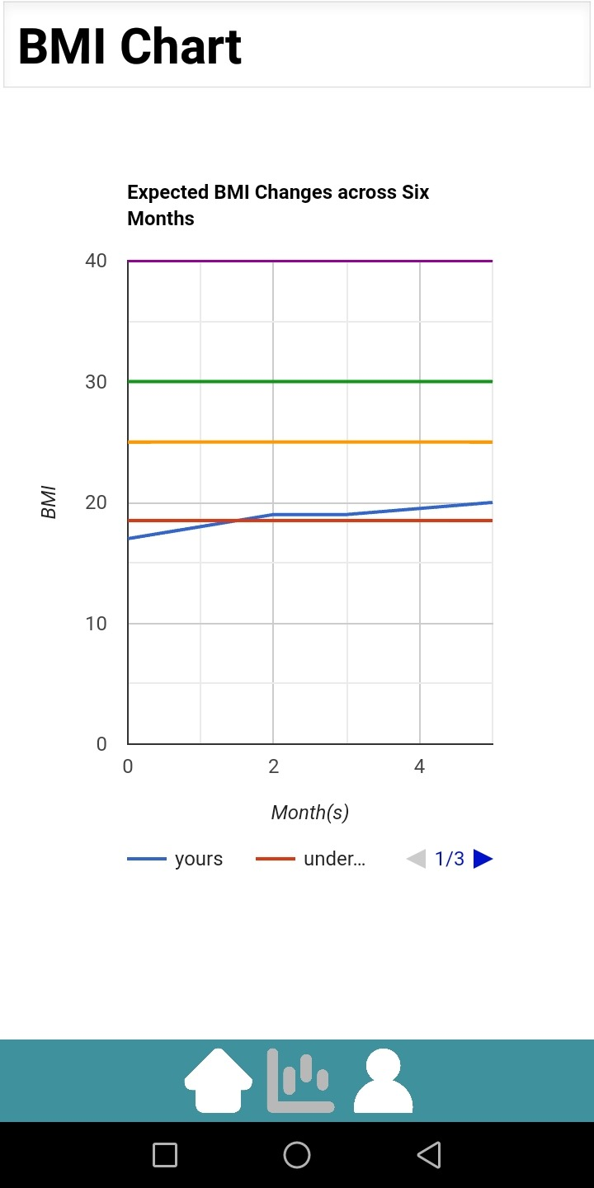

* 1. Overweight- BMI are expected to decrease towards Normal range across 6 months.

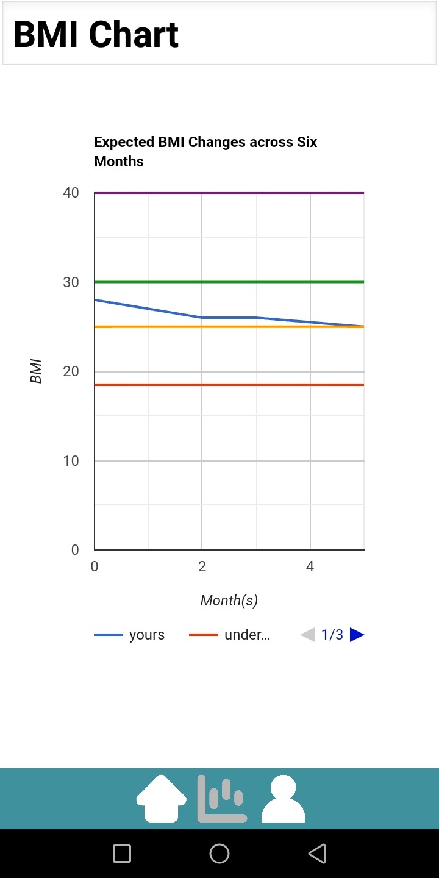

* 1. Obese- BMI are expected to decrease towards Overweight range across 6 months.

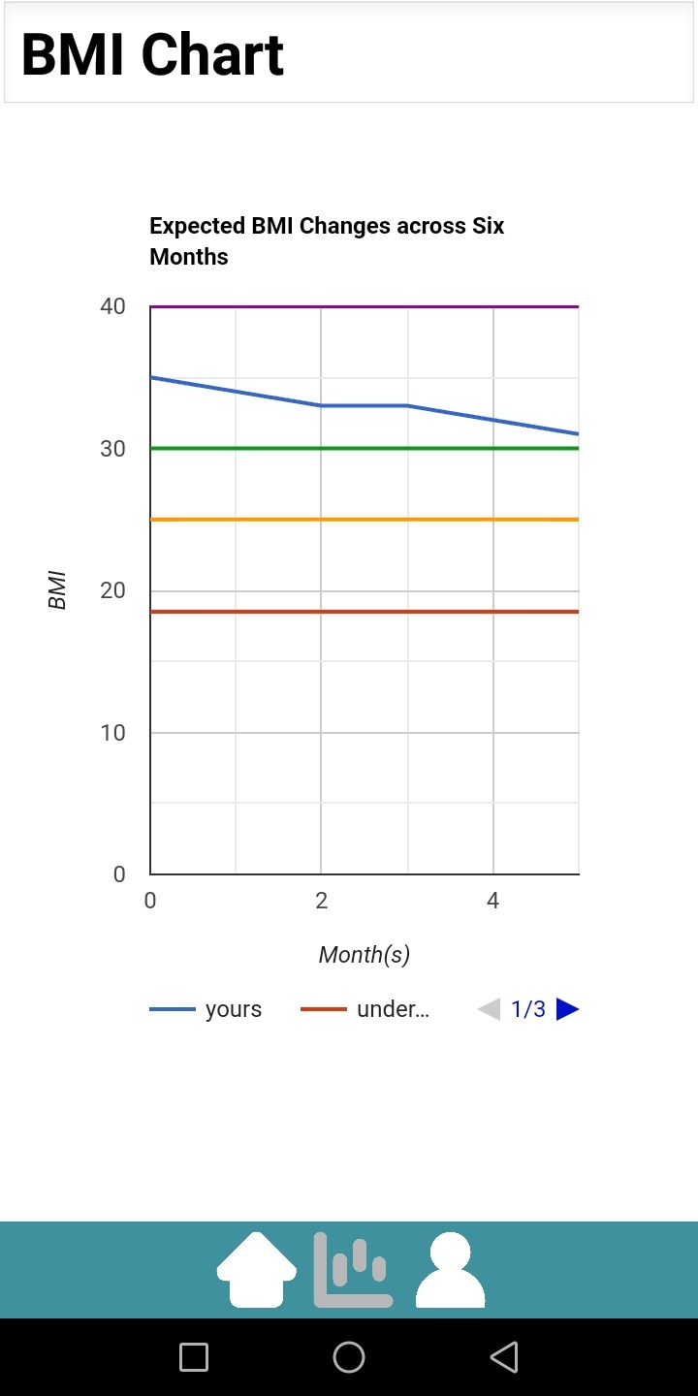

**BMI Calculator (Child)**

1. Below displays the BMI calculation for female child named Jane aged 8. Child BMI works the same as adult. However, the range of child’s BMI change according to gender and age range.



1. The output of BMI consists or normal, underweight, overweight, and obese.
   1. Normal

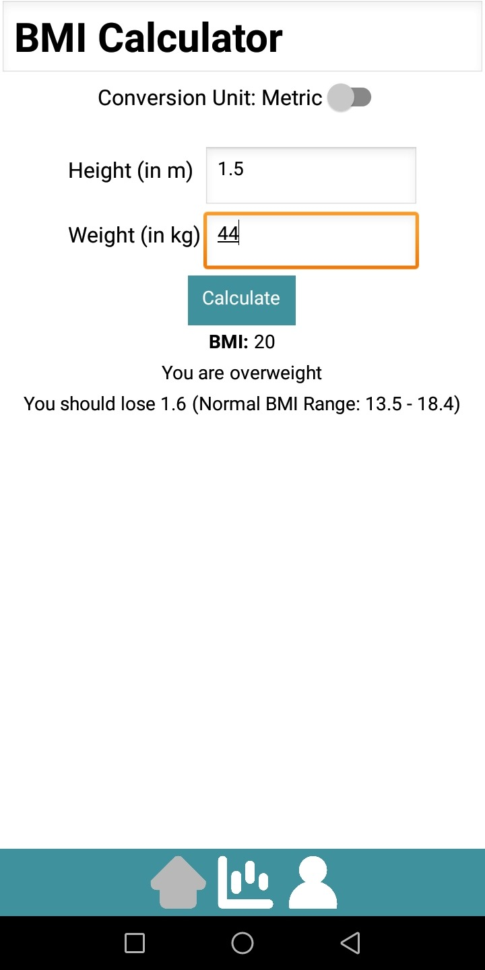

* 1. Underweight

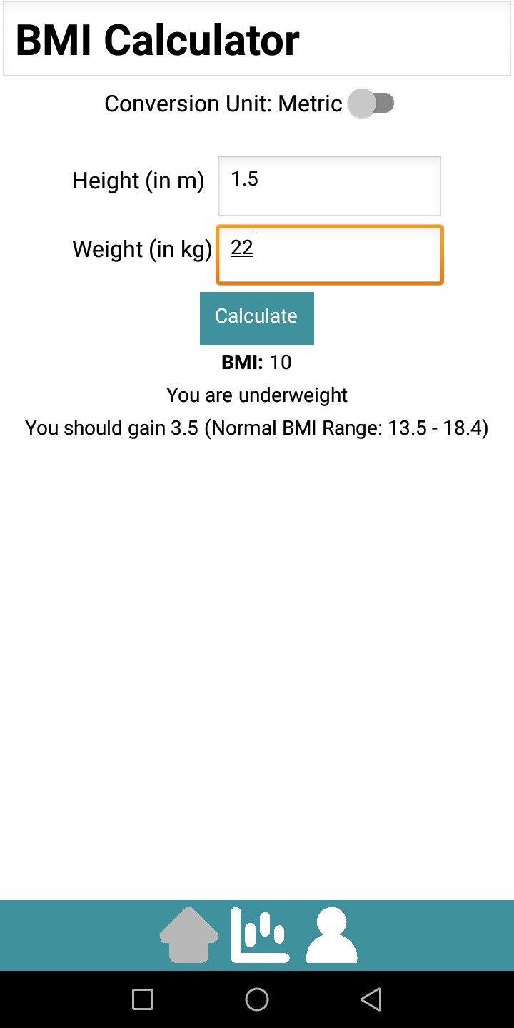

* 1. Overweight



* 1. Obese.

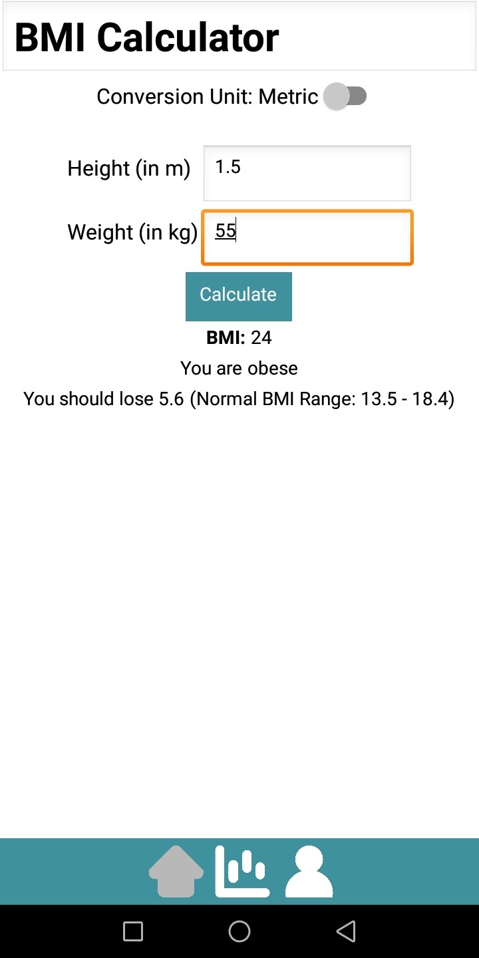

**BMI Chart (Child)**

1. The BMI Chart will display the BMI range in table form of different gender for child aged from 2 to 20 with BMI range of normal, underweight, overweight, and obese.
   1. BMI Chart for girls aged from 2 to 20.

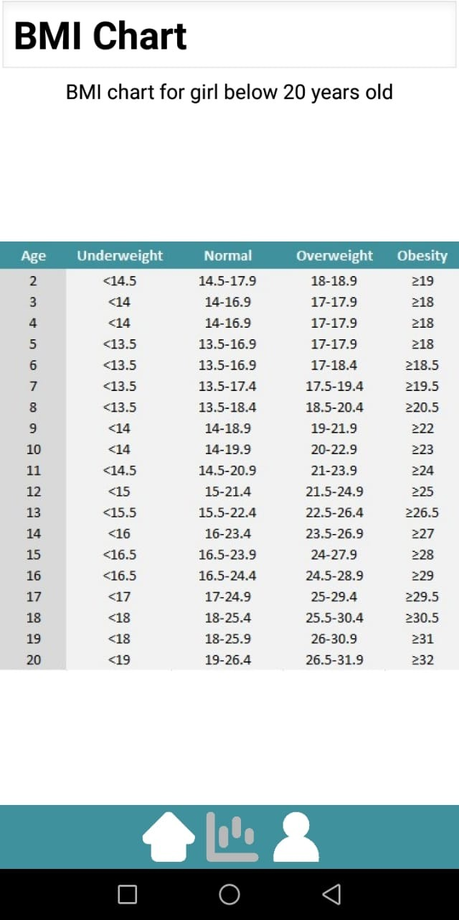

* 1. BMI Chart for boys aged from 2 to 20.

